https://www.quora.com/What-is-machine-learning-4

****************************************************************************************************
A doctor based on the medical history of the patient and some current symptoms predicts that he has some sort of illness.
A stock-broker knows when to buy/sell which stocks based on his experience in the past.
You can tell where to take a turn when a specific landmark appears in front of you.

Taking the above abilities of humans and trying to have them learn by a machine without explicitly writing code, is machine learning.
There is a slight difference here. Machines can carry out all the tasks we can but just with extra abilities which we aren't capable of like:
- Analysing tons and tons of data at a single time.
- Non-tiring performance
- Patience
- Efficient memory access.
The process where a machine becomes capable of the major quality that seperates living beings from non-living beings is to learn from experiences, is called machine learning.

Think of ML as a recipe to learn an algorithm. The recipe is:
- Learn from past experience of tasks
- Continue to carry out tasks
- Raise performance with each experience gained
How to raise performance with increasing experience is the algorithm it teaches itself with the help of the recipe.
******************************
A machine is said to learn if and only if it increases it's performance with each gaining experience.
The main objective of Machine Learning algorithms is to teach computer how to learn by itself. We say, that the computer is learning, if its performance is increasing with experience. We know how humans become proficient with experience. In the same way, Computer needs to be experienced.
The experience is created with data that may be in the form of text, image, audio, video etc. Let us say, I want to teach computer differentiate between cat and dog images. That means, given an image a computer should tell us, if it is a cat or dog. So, the experience is created by exposing the computer with many examples or set of cats and dogs images which are labeled. Here, every image is labeled with either cat or dog.
There are different types of Machine Learning algorithms, Supervised, Unsupervised, Reinforcement algorithms. The most popular and easy to understand is supervised learning algorithm. It works in two phases, the training and testing. In training phase, we give these labeled data to the algorithm and it learns the relation or mapping between the images and its corresponding label. Here, the image is considered as input (x) and the label is considered as output (y).The labels for this example may be assigned as 0 for cat and 1 for dog. It’s like, we know x and y , but we do not the relation between these two. Means, we do not know how does y (the label) changes if x (input image) changes. Mathematically, the relationship may be given as,
Y=f(x)
Basically, ML algorithm is mathematical based and it is trying to learn a function (f) with given set of x and y (the dataset). After solving the equation during training, we know the function f, which also referred as ML model.
Now we go for testing phase, where we try to evaluate the learnt function f for its accuracy. When we give x , the input image of a cat or dog , the model gives the out y’, the predicted label using the equation given above. It y’ is near to value 0, we declare it as image of a cat , otherwise, the image is of dog.
ML Model (f)
We need to compare this y’ (the predicted label) with the y (actual label) to know how perfectly the algorithm is working. It the accuracy is good like, above 96%, we may use the algorithm for real – world data.
The performance of any Ml algorithm is largely dependent on the right set and amount of data that we have. The one who has the best data is the winner.
The most crucial part in understanding ML concept is to understand how we compute function f. There are many algorithms, like, Artificial Neural Network, Support Vector Machine, Bayesian Classifier etc have different means to derive f.
**************************************
Machine Learning is programming computers to optimize performance using example data or past experience. It allows a computer to extract information from the past data. For example, Our human brain itself works on machine learning concept. Every time, when we see a new object then our brain stores the information about that object like name, dimension, color etc. The next time when we see the same or similar object then it uses data which was stored earlier regarding that object and In this way, it helps us recognize new objects.
The industry uses machine learning to optimize their revenue by finding useful patterns with the help of the historical data.
Now the question arises, There are multiple machine learning algorithms available to solve problems. How to choose one?

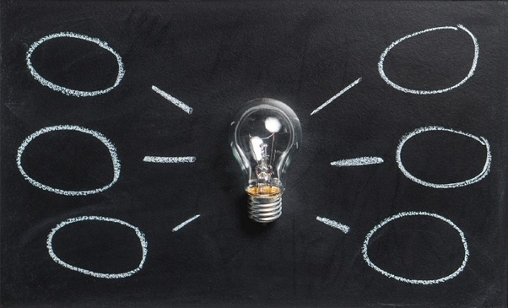
1

